Bigmart Sales Data
This is short summary about my python + notebook knowledge, where I tried to read csv data in google colab and try some scripts of code to analyze the data. Here, I review few rows of dataset from top and try to learn about columns. I also try to summarize dataset by Item weight, Outlet_Size, count number of items in each Item_Type and Outlet_Size.
- Reading csv file-
Code:
- pandas library is imported as pd
- read csv file as DataFrame and data is named.

- Review Dataset
Code:
- Use head() function to review first 5 rows of dataset,
Output:
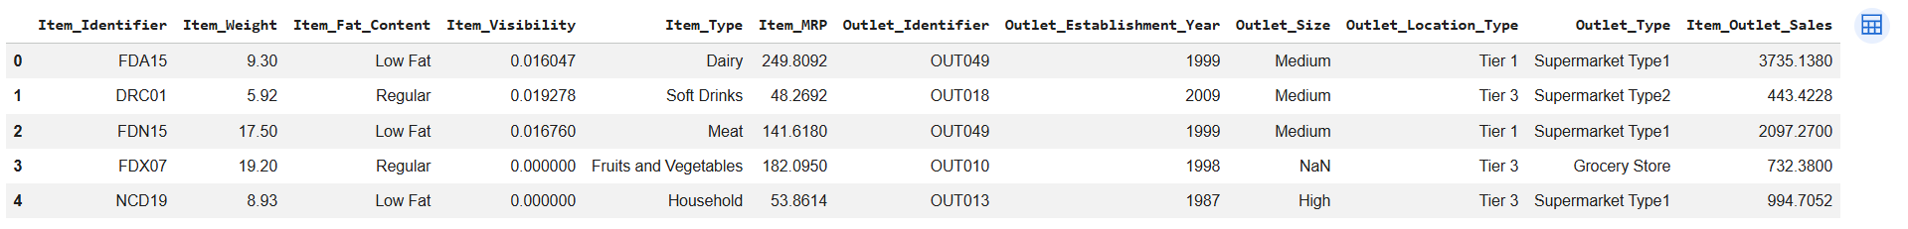

- Summary Table
Code:
- First line of code, creates a summary table that shows the average mean of Item_Weight for each category in the Item_Type column.
- Second line of code, rename the column name from Item_Weight to Mean_Weight
- Third line of code, pivot is showing a summary table of dataset

Output:
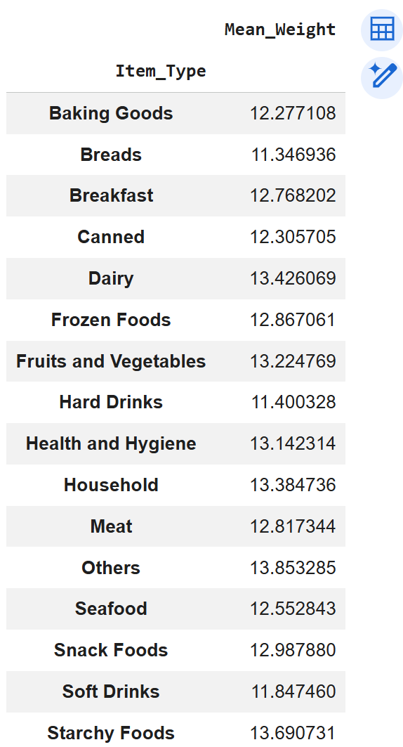

Code:
- A table summary of average Item Price by Outlet_Size and Outlet_Type

Output:
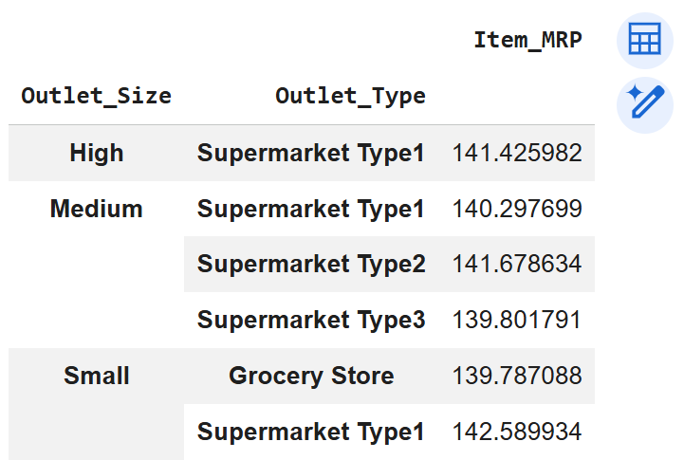

- Frequency Table
Code:
- crosstab() creates a frequency table (contingency table) that counts how many times each combination of Outlet_Size and Item_Type occurs in your data.

Output:
